Clockwise Orientation

Definition
# Source: AI Source: Provided by: [Data Path: Persons Table -> ID Column: 1, Name_En Column: Motasem Essam] -> From: [ChatGPT] on [7/20/2026]
Clockwise Orientation describes the direction in which an object is rotated or oriented following the same direction as the hands of a traditional clock. The rotation proceeds from the top toward the right, then downward, leftward, and back upward.
Clockwise orientation is widely used to describe rotational direction in geometry, engineering, mechanics, physics, robotics, navigation, and computer graphics.

Characteristics
# Source: AI Source: Provided by: [Data Path: Persons Table -> ID Column: 1, Name_En Column: Motasem Essam] -> From: [ChatGPT] on [7/20/2026]
A clockwise orientation:
- Follows the direction of a clock's hands.
- Represents a rotation, not a translation.
- Changes an object's direction without changing its size or shape.
- Is measured relative to a chosen reference direction.
- Can be described using degrees or radians.

Illustration
# Source: AI Source: Provided by: [Data Path: Persons Table -> ID Column: 1, Name_En Column: Motasem Essam] -> From: [ChatGPT] on [7/20/2026]
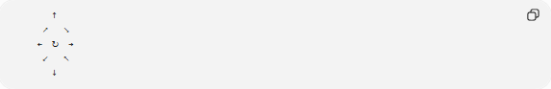
↑
↗ ↘
← ↻ →
↙ ↖
↓
The curved arrow indicates clockwise rotation.

Clockwise Rotation
# Source: AI Source: Provided by: [Data Path: Persons Table -> ID Column: 1, Name_En Column: Motasem Essam] -> From: [ChatGPT] on [7/20/2026]
If an object starts facing upward, a clockwise rotation changes its orientation as follows:
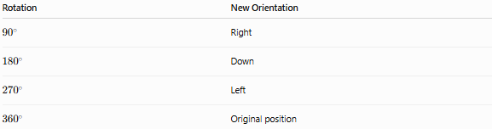
Rotation | New Orientation
$${90}^{∘}$$ | Right
$${180}^{∘}$$ | Down
$${270}^{∘}$$ | Left
$${360}^{∘}$$ | Original position

Angle Measurement
# Source: AI Source: Provided by: [Data Path: Persons Table -> ID Column: 1, Name_En Column: Motasem Essam] -> From: [ChatGPT] on [7/20/2026]
Clockwise orientation is commonly represented by rotation angles.
Examples:
- ${45}^{∘}$
- ${90}^{∘}$
- ${180}^{∘}$
- ${270}^{∘}$
- ${360}^{∘}$
In some mathematical conventions, clockwise rotations are represented by negative angles, while counterclockwise rotations are positive.
Example:
$$-{90}^{∘}$$
represents a 90° clockwise rotation.

Examples
# Source: AI Source: Provided by: [Data Path: Persons Table -> ID Column: 1, Name_En Column: Motasem Essam] -> From: [ChatGPT] on [7/20/2026]
Clockwise orientation can be observed in:
- Clock hands
- Steering wheels
- Door knobs
- Screws (tightening in most cases)
- Rotating machine shafts
- Wind-up mechanisms
- Rotating gears

Applications
# Source: AI Source: Provided by: [Data Path: Persons Table -> ID Column: 1, Name_En Column: Motasem Essam] -> From: [ChatGPT] on [7/20/2026]
Clockwise orientation is used in:
- Geometry
- Engineering
- Mechanical Design
- Robotics
- Physics
- Navigation
- CAD (Computer-Aided Design)
- Computer Graphics
- Animation
- Manufacturing

Advantages
# Source: AI Source: Provided by: [Data Path: Persons Table -> ID Column: 1, Name_En Column: Motasem Essam] -> From: [ChatGPT] on [7/20/2026]
Clockwise orientation:
- Provides a standard reference for rotation.
- Simplifies motion description.
- Supports mechanical design.
- Improves communication in technical drawings.
- Enables accurate rotational measurements.

Limitations
# Source: AI Source: Provided by: [Data Path: Persons Table -> ID Column: 1, Name_En Column: Motasem Essam] -> From: [ChatGPT] on [7/20/2026]
Clockwise orientation:
- Depends on the observer's viewpoint.
- May differ between mathematical and engineering sign conventions.
- Requires a defined reference direction.

Comparison with Other Orientations
# Source: AI Source: Provided by: [Data Path: Persons Table -> ID Column: 1, Name_En Column: Motasem Essam] -> From: [ChatGPT] on [7/20/2026]
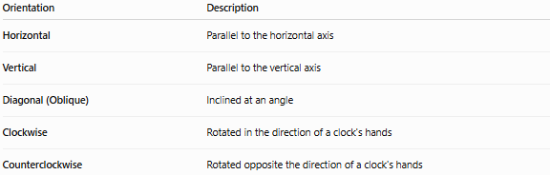
Orientation | Description
Horizontal | Parallel to the horizontal axis
Vertical | Parallel to the vertical axis
Diagonal (Oblique) | Inclined at an angle
Clockwise | Rotated in the direction of a clock's hands
Counterclockwise | Rotated opposite the direction of a clock's hands

Key Points
# Source: AI Source: Provided by: [Data Path: Persons Table -> ID Column: 1, Name_En Column: Motasem Essam] -> From: [ChatGPT] on [7/20/2026]
- Clockwise Orientation follows the direction of a clock's hands.
- It describes rotational direction, not object position.
- Rotation may be measured in:
  - Degrees (°)
  - Radians
- In mathematics, clockwise rotation is often represented by negative angles.
- Clockwise orientation is widely used in engineering, mechanics, robotics, CAD, and geometry.

Conclusion
# Source: AI Source: Provided by: [Data Path: Persons Table -> ID Column: 1, Name_En Column: Motasem Essam] -> From: [ChatGPT] on [7/20/2026]
Clockwise Orientation describes the rotational direction that follows the movement of a clock's hands. It is a fundamental concept for representing and measuring the direction of rotation in geometry and many technical disciplines. By providing a consistent reference for angular movement, clockwise orientation supports engineering, mechanical systems, robotics, computer graphics, navigation, manufacturing, and scientific analysis, where precise rotational direction is essential.

